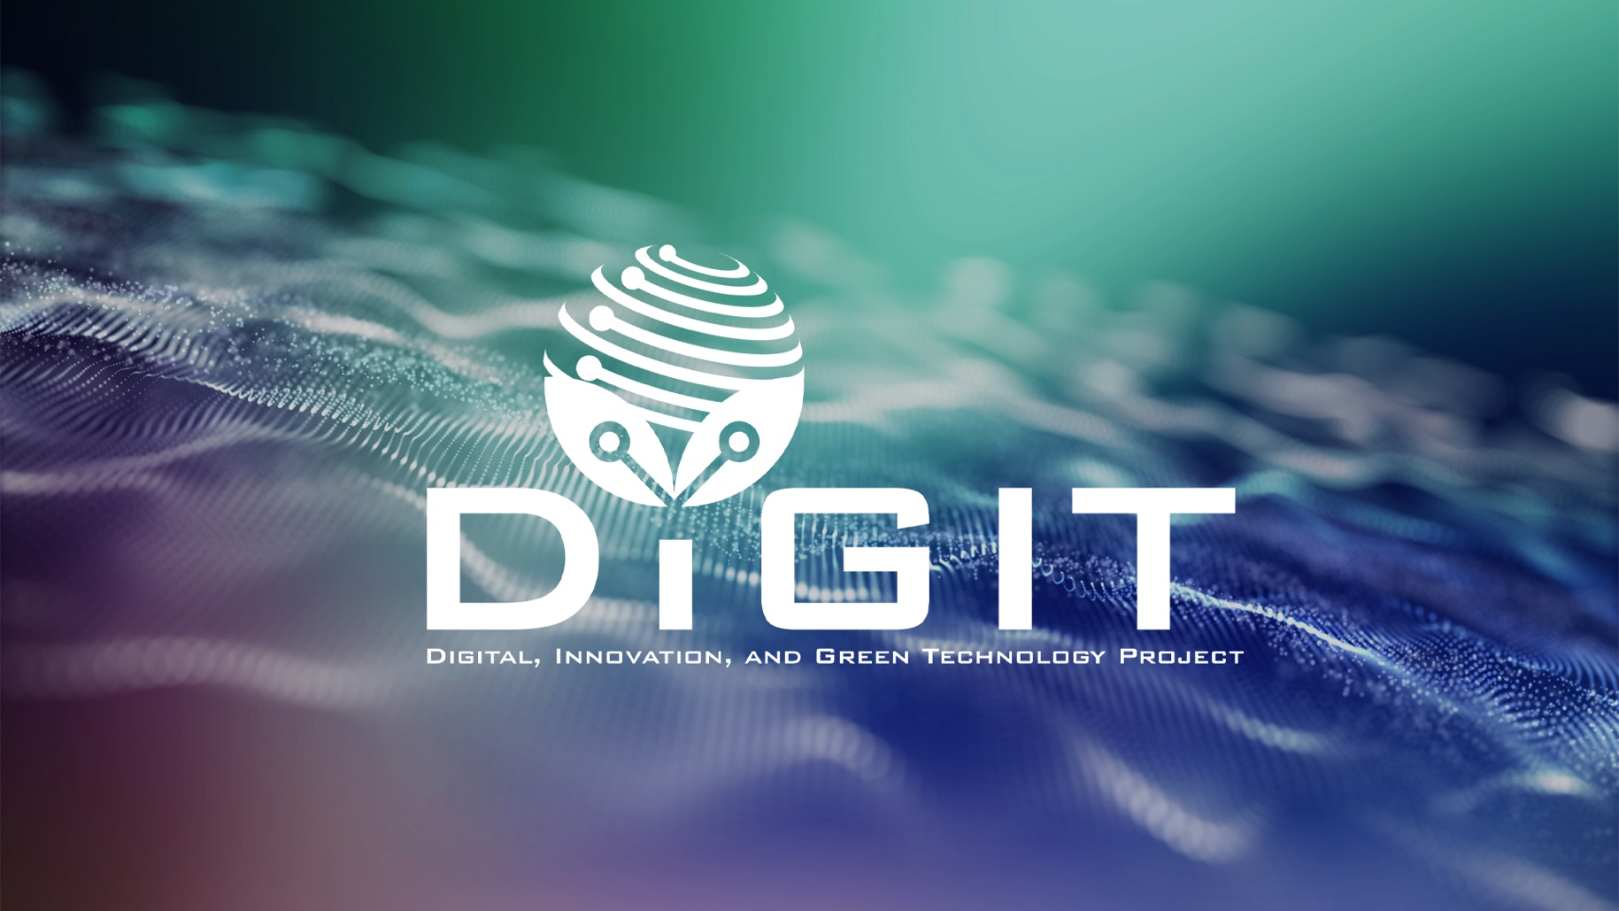

DIGITAL, INNOVATION, AND GREEN TECHNOLOGY PROJECT
(DIGIT PROJECT)




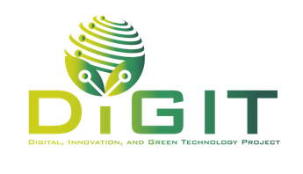

REPUBLIC OF CROATIA
MINISTRY OF SCIENCE, EDUCATION AND YOUTH
Donje Svetice 38, Zagreb 10 000, Croatia

DIGITAL, INNOVATION, AND GREEN TECHNOLOGY PROJECT (DIGIT PROJECT)
IBRD LOAN NO. 9558-HR
PROJECT ID: P180755



Annex VI. Business Development Plan for Research Center

CALL FOR PROPOSALS
PROFESSIONALIZATION OF RESEARCH CENTERS – SECOND CALL
CALL REFERENCE NUMBER: DIGIT.1.2.04

July 2026
Business Development Plan for Research Center
Instructions for completing the document
This document provides guidance to applicants on the expected structure and content of the Business Development Plan (BDP) for the Research Center. Applicants are required to follow this structure when preparing the BDP and to provide all relevant information under the indicated sections. The BDP should present a clear and structured description of the current situation, key challenges, development strategy, planned activities, expected results, and financial and sustainability plans related to the Research Center. The maximum length of the Business Development Plan is 30 pages, excluding two front pages of this template and annexes (only documents supporting the statements and information provided in the BDP, e.g. CVs of key staff, equipment lists, previous projects). If the Applicant submits a BDP longer than 30 pages, the pages exceeding the prescribed limit will not be taken into consideration during the evaluation process. The document must be prepared using Times New Roman font size 11, written in clear and concise language, avoiding unnecessary descriptive content. Sections of this template must not be extracted from the document in separate annexes.
Important note:
The Business Development Plan is a key project document and must be fully aligned with the information provided in other parts of the project application, particulary with the Application Form submitted through the eDIGIT portal.

Executive Summary (max 1 page)
The summary should clearly define the Research Center covered by the project, including the organizational units, laboratories, facilities, research infrastructures, and support functions that form part of the RC. The summary must briefly describe the main activities, the overall and specific objectives of the project, showing how they will lead to the expected expected outputs, outcomes and impacts within the planned timeframe and resources.

2. Current state & Options for Development of Research Center

2.1 Organizational & Resources Overview
- Brief overview of the organisational structure of the Research Centre, including relevant management. Describe the roles and experience of key staff members involved in the implementation of the BDP. Where applicable, refer directly to demonstrated capacities outlined in the CVs.
- Overview of the existing research infrastructure and equipment with year of purchase. Include the value of infrastructure in EUR
- Overview of key resources (knowledge, data, technologies, products, and people) owned, used or developed by the RC, including the year of creation or acquisition for each resource.
- Description of key existing processes (both internal and external) to be improved/developed through the project (link with relevant indicator(s)): current mechanisms related to infrastructure utilisation, private sector collaboration, research commercialisation and financial sustainability (including short background information when and how these processes were developed/introduced).

2.2 Current services & clients
Overview of the existing services offered by the Research Centre, with relevant key statistics and the year each service was established. Focus in particular on the following types of services:
- Access to infrastructure (e.g., renting of equipment or research staff time): indicate the number of equipment units and provide usage statistics (e.g., number of users, number of sessions, total hours of use),
- Analytical services,
- Contract research and development (R&D): number of contracts and total value of projects,
- Collaborative R&D: number and total value of projects.
Present comprehensive data on the overall utilization of research infrastructure, regardless of user type. This should include information on the categories of users (e.g., internal staff, external research organisations, industry partners) and their usage patterns. The aim is to provide a clear picture of how the infrastructure is currently used and to identify underutilised capacities and opportunities for broader access and collaboration.
Include a summary of key users or user groups, their needs, and examples of services or solutions provided to them. A list of key users and projects may be included as an annex.

2.3 Recent initiatives
Overview of key recent initiatives and their contribution to infrastructure utilisation, private sector collaboration, research commercialisation and financial sustainability. Specify the key initiatives, place them in temporal context and provide some key indicators related to them (for example, the number of projects submitted to certain types of calls demonstrating efforts to advance existing knowledge; the number of fairs attended reflecting attempts to find commercialisation partners; the number of potential collaborative projects or contract research opportunities evaluated etc.).

2.4 Current results
Overview of current/previous status (covering last 3 years prior to this project’s submission, if available) of key operational indicators related to infrastructure utilisation, private sector collaboration, research commercialisation and financial sustainability. Include all relevant indicators that will be tracked within the Research Center. Some indicators can be introduced within the project if they have not been previously tracked but are considered relevant.

2.5 Key challenges
Provide an analysis/summary of the main challenges facing the Research Center, also taking into account the following areas:
- Professionalization of organizational and operational model (examples of some challenges and gaps):
  - Gaps in management/technical/administrative capacities,
  - Gaps/weaknesses in processes related to the management of Research Center (utilisation, commercialisation, collaboration, sustainability),
  - Level of integration with existing research activities of the Applicant’s institution, with research community,
  - Connect gaps with new Business Development Manager role
- Optimized and transparent access to research infrastructure and services (examples of some challenges and gaps):
  - Availability/lack of information on utilisation of research infrastructure,
  - Access to infrastructure and services (including modes of usage, pricing, transparency, etc.),
  - Utilisation of infrastructure and services (internal, external),
- Enhanced capacity of Research Center staff (examples of some challenges and gaps):
  - Gaps in knowledge and understanding of needs of private sector users/potential users,
  - Gaps/weaknesses in the ability to satisfy private sector needs,
- Strengthened collaboration with industry and other research infrastructures (examples of some challenges and gaps):
  - Level of integration with technology transfer processes and related ecosystem,
  - Collaboration with industry though collaborative and contract R&D,
- Increased visibility and user base of the Research Center (examples of some challenges and gaps):
- Limited recognition of Research Center’s capacities among potential users and stakeholders,
- Lack of targeted outreach and promotional activities (e.g., marketing materials, online presence),
- Absence of strategic communication aimed at expanding the user base (academia, industry, public sector),
- Insufficient data on current users and usage patterns to guide visibility strategies,
- Weak positioning in relevant national and international networks and platforms.
This list is not exhaustive list. The Applicant should adress key challenges relevant to their project and Research Center.

2.6 SWOT analysis
Provide a SWOT analysis based on identified challenges and other information on current status of the Research Center.

2.7 Opportunities for further development of client base and services
Based on the identified internal and external challenges, opportunities and threats outline potential opportunities/directions for further development. This may include expanding cooperation with existing clients, finding new ones as well as improving, changing, extending, streamlining, or introducing new services. Additionally, describe potential opportunities for improving existing processes or introducing new ones.

3. Strategy & Objectives

3.1 Strategic goals
Outline the key strategic goals of the Applicant institution related to innovation, entrepreneurship, commercialisation. Describe the contribution of the Research Center to achieving these goals.
Additionally, describe how the Research Center aligns with national and EU strategies and strategic documents, as well as with relevant international infrastructures, if any.

3.2 Key objectives of the Business Development plan
List the key objectives of this business development plan. Ensure that the objectives are clearly defined, specific, measurable, attainable, and aligned with the goals of the Call.
The objectives of the Research Center should focus on the strategic enhancement of organizational capacity, optimization of research infrastructure usage, and strengthening collaboration with industry. The Business Development Plan should address the following types of objectives:
- Professionalization of organizational and operational model (including establishment of professional Business Development Manager function)
- Optimized and transparent access to research infrastructure and services
- Enhanced capacity of Research Center staff
- Strengthened collaboration with industry and other research infrastructures
- Increased visibility and user base of the Research Center

3.3 Key indicators
Define key indicators to be achieved during the project and in the post-implementation period. Please take into account the requirements in the Theory of Change and results framework outlined in the Guidelines for Applicants.
Data on outcome and impact indicators will be collected up to five years following project completion via post-implementation reports or surveys. By applying to the Call, the applicants consent to being contacted by MSEY after project completion.
As a baseline value, please provide data from the 3 years preceding the submission of the project proposal.
Additionally, the Applicant may include further operational indicators (optional) to track infrastructure utilization, service usage, knowledge creation, collaborative practices, coverage of costs by industry, revenue generation, sustainability, expansion of user base, etc. In this case also provide historical and future value as described above.

Indicator name | Level (impact, output or outcome) | Baseline value | Target value | Deadline for achievement | Reporting frequency | Rationale for achievement | Note regarding the selection of indicators*
O1 Number of intellectual property applications filed | Impact |  |  |  | annually after project completion |  | Applicants are required to select the indicator and set a target value for it at the project level. Indicator selection is mandatory.
O2 Number of technology transfers realized | Impact |  |  |  | annually after project completion |  | Applicants are required to select the indicator and set a target value for it at the project level. Indicator selection is mandatory
O3 Share of revenue from technology transfers on annual basis | Impact |  |  |  | annually after project completion |  | Applicants are required to select the indicator and set a target value for it at the project level. Indicator selection is mandatory.
O4 Share of revenue from services provided on annual basis | Impact |  |  |  | annually after project completion |  | Applicants are required to select the indicator and set a target value for it at the project level. Indicator selection is mandatory.
A1 Number of research infrastructure management processes introduced or upgraded | Outcome |  |  |  | annually after project completion |  | Applicants are required to select the indicator and set a target value for it at the project level. Indicator selection is mandatory.
A2 Number of staff who apply new skills and knowledge | Outcome |  |  |  | annually after project completion |  | Applicants are required to select the indicator and set a target value for it at the project if the project proposal includes staff participating in training.
Aa1 Number of research infrastructure management process introductions or upgrades initiated | Output |  |  |  | at project completion |  | Applicants are required to select the indicator and set a target value for it at the project level. Indicator selection is mandatory.
Ab1 Number of staff participating in training | Output |  |  |  | semi-annually |  | Applicants are required to select the indicator and set a target value for it at the project if the project proposal includes staff participating in training.
B1 Number of collaborative projects contracted after project completion (between research organizations and enterprises) | Outcome |  |  |  | annually after project completion |  | Applicants are required to include the indicator and set a target value at project level. Indicator selection is mandatory.
B2 Number of contracted projects for providing services to the economy | Outcome |  |  |  | annually after project completion |  | Applicants are required to include the indicator and set a target value at project level. Indicator selection is mandatory.
C1 Number of unique infrastructure users on annual basis | Outcome |  |  |  | annually after project completion |  | Applicants are required to include the indicator and set a target value at project level. Indicator selection is mandatory.
C2 Number of hours of equipment utilization on annual basis | Outcome |  |  |  | annually after project completion |  | Applicants are required to include the indicator and set a target value at project level. Indicator selection is mandatory.
BCa1 Number of networking events organized and attended | Output |  |  |  | semi-annually |  | Applicants are required to include the indicator and set a target value at project level if the project proposal includes organizing or attending networking events.
BCa2 Number of participants at networking events organized | Output |  |  |  | semi-annually |  | Applicants are required to include the indicator and set a target value at project level if the project proposal includes organizing networking events.
BCb1 Number of research infrastructure visibility events organized | Output |  |  |  | semi-annually |  | Applicants are required to include the indicator and set a target value at project level if the project proposal includes organizing visibility events.
BCb2 Number of participants at research infrastructure visibility events organized | Output |  |  |  | semi-annually |  | Applicants are required to include the indicator and set a target value at project level if the project proposal includes organizing visibility events.
Optional indicator 1 (if planned) | … | … | … | … | … | … | Applicants are required to include the indicator and set a target value at project level if the project proposal includes optional indicator.
Optional indicator 2 (if planned) | … | … | … | … | … | … | Applicants are required to include the indicator and set a target value at project level if the project proposal includes optional indicator.

* - this column is only to guide the applicant when filling in the table with mandatory and optional indicators.Applicants can delete the column from final table

4. Development Plan & Operationalization
Development plan should cover eligible activities and sub-activities according to eligibility conditions and objectives:
- Professionalization of organizational and operational model (including activities related to establishment of role of Business Development Manager);
- Optimized and transparent access to research infrastructure and services;
- Enhanced capacity and competences of Research Center staff;
- Strengthened collaboration with industry and other research infrastructures;
- Increased visibility and user base of the Research Center.
Project duration (max 24 months, no longer than 31 October 2028)
Implementation start date

Duration of implementation (months)

Name of the activity | Start month of activity implementation | Duration of activity implementation | Description of the activity | Deliverables
<Activity 1> |  |  |  | <Deliverable 1>  <Deliverable 2>  <Deliverable 3>
<Activity2> |  |  |  | <Deliverable 4>  <Deliverable 5>
<Activity 3> |  |  |  | <Deliverable 6>
Please add as many lines as needed.

5. Budget & Financial Plan

5.1 Budget overview
The budget for the Business Development Plan (Project) is structured over a 3-year period and is aligned with the eligible cost categories.
Below is a suggested budget template for project’s implementation period. Additional lines could be introduced. Provide justification for each cost.
Activity | Cost name | Cost category | Funding category | Number of units | Unit cost | Total | Description
 | [Business Development Manager] | <Direct costs – personnel> | <Research organizations>
 | [Employee 2] | <Direct costs – personnel> | <Research organizations>
 | [Cost 1] | <Direct cost - other> | <Research organizations>
 | [Cost 2] | <Direct cost - other> | <Research organizations>
 | [Cost 1] | <Direct cost - other> | <Research organizations>
 | [Cost 1] | <Direct cost - other> | <Research organizations>
 | …… | <Direct cost - other> | <Research organizations>

5.2 Financial Plan
Financial plan includes all revenues (including project revenues) and all costs (including those covered by the project).
Revenue Category | 2025 | 2026 | 2027 | 2028 | 2029 | 2030 | 2031 | 2032 | 2033 | Total (€)
Project Revenues
Access to Infrastructure
Analytical Services
Contract R&D
Collaborative R&D
Other Revenues
Total revenues

Cost Category | 2025 | 2026 | 2027 | 2028 | 2029 | 2030 | 2031 | 2032 | 2033 | Total (€)
Personnel Costs
Research & Laboratory Costs
Equipment & Infrastructure
Facilities & Utilities
Digital Infrastructure
Collaboration & Networking
Communication & Dissemination
Project Management & Administration
Other
Total costs

6. Risk Management & Sustainability Strategy

6.1 Identified risks and mitigation strategies
In the table, list the identified project implementation risks and, for each risk, assess the probability (low/medium/high) and impact (low/medium/high), and describe the mitigation or avoidance measures.
Risk | Probability (low/medium/high) | Impact (low/medium/high) | Mitigation or avoidance measures

6.2. Sustainability strategy
The applicant is required to describe the long-term sustainability strategy for the Research Center, addressing the following key areas:
- Human resources (plans to ensure the availability and retention of skilled personnel, talent management strategies, measures for continuous training and capacity building to enhance relevant business development, technology transfer, intellectual property rights, collaboration competencies and leadership),
- Activities (sustaining core activities such as infrastructure utilization, service delivery, and post-project collaboration with industry, mechanisms for maintaining and upgrading infrastructure and services, as well as strategies for expanding service in response to market demand),
- Financing (strategies for securing diversified revenue streams, including income from services and contract and collaborative projects, national/EU grants, public-private partnerships etc. An elaborate revenue projection should be provided within Financial plan section),
- Institutional Integration (further alignment with the Applicant institution’s strategic goals, including the creation of relevant synergies in knowledge, capacities and processes between the Applicant and Research Center).
Detail sustainability mechanisms, such as knowledge transfer programs or institutional frameworks, aimed at preserving and continuing project benefits post-completion.

7. Annexes
List the annexes you are submitting with BDP.

