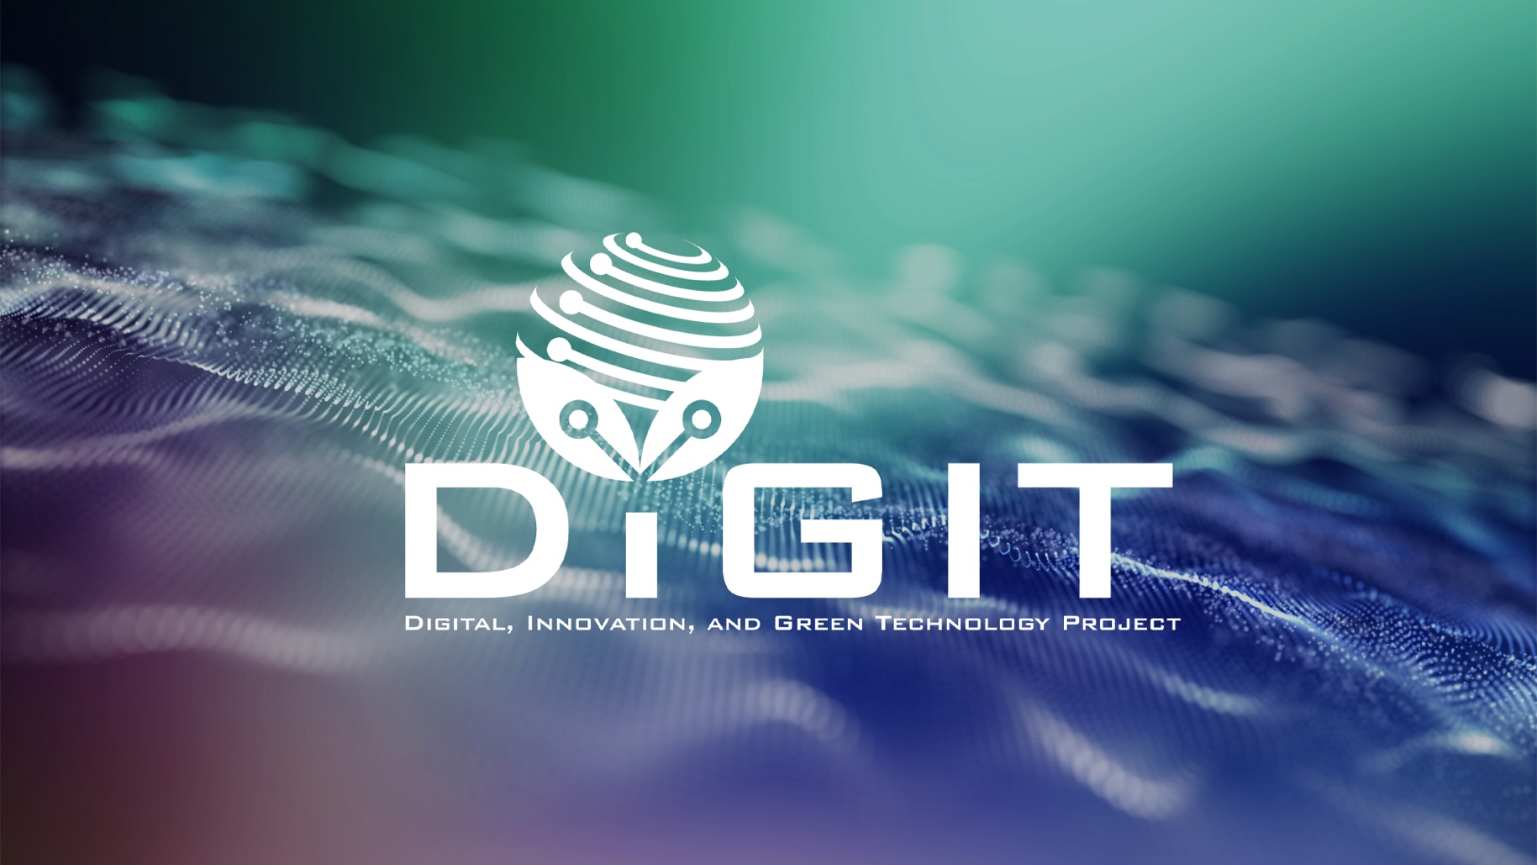

DIGITAL, INNOVATION, AND GREEN TECHNOLOGY PROJECT
(DIGIT PROJECT)


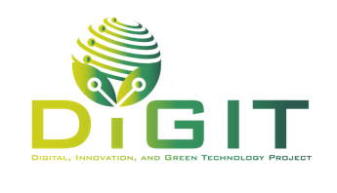

REPUBLIC OF CROATIA
MINISTRY OF SCIENCE, EDUCATION AND YOUTH
Donje Svetice 38, Zagreb 10 000, Croatia

DIGITAL, INNOVATION, AND GREEN TECHNOLOGY PROJECT
(DIGIT PROJECT)
IBRD LOAN NO. 9558-HR
PROJECT ID: P180755

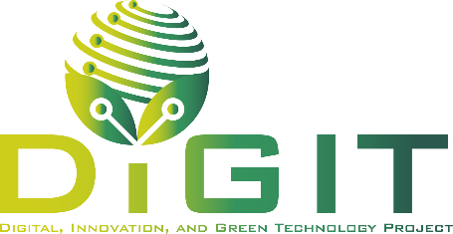

ANNEX IV. APPLICATION FORM

CALL FOR PROPOSALS
SUPPORT PROGRAM FOR APPLIED RESEARCH AND KNOWLEDGE (SPARK)
CALL REFERENCE NUMBER: DIGIT.2.1.03

May 2026
Application form
Note: This Application form should be completed through the online portal. Ensure that each section is filled thoroughly and according to the guidelines provided.

1. Project overview
Project Information
Project title: | <Name of the project>
Name of the Applicant: | <Name of the company>
Addressed group: | <Group A: Digital R&D>  <Group B: Green R&D>
Predominant scientific area of the project proposal (1)
Predominant scientific field of the project proposal (1)
Secondary scientific areas of the project proposal (if applicable)
Predominant S3 thematic priority area (1) | Select from the list:  <Personalized Health Care>  <Smart and Clean Energy>  <Smart and Green Mobility>  <Security and Dual-Use>  <Sustainable and Circular Food>  <Customized and Integrated Wood Products>  <Digital Products and Platforms>
Secondary S3 thematic areas (if applicable) (if applicable) | Select from the list:  <Personalized Health Care>  <Smart and Clean Energy>  <Smart and Green Mobility>  <Security and Dual-Use>  <Sustainable and Circular Food>  <Customized and Integrated Wood Products>  <Digital Products and Platforms>
Predominant sector (section) (NACE rev. 2.1) (if applicable)
Predominant activity (class) (NACE rev. 2.1) (if applicable)
Please indicate whether the project includes women among any of the following: firm owner, CEO, research team lead) | <Yes>  <No>
Keywords related to the project proposal (max. 200 characters) | Provide a concise list of keywords that best describe key project elements, such as the innovative solution, its intended application, sectoral relevance, technological domain, or other relevant aspects.
Project duration: | <Proposed project start and end dates (maximum 16 or 22 months, depending on thematic group addressed)>
Total budget: | <Total project budget in euros>
Total grant amount: | <Total grant amount in euros>
Project objectives: | <Overall objective(s)>  <Specific objective(s)>
Project activities: | <List the main activities planned under the project>
Target group(s): | <List the main target groups/entities who will directly benefit from the project>
Location of the project:
Project summary (max. 750 characters, including spaces) | <Provide a concise description of the project, clearly explaining the main problem or challenge addressed, the proposed solution, and the key results and objectives to be achieved. The summary should highlight the relevance of the project.>

Applicant/Consortium information
Please fill in the fields in the table with information for the project applicant,) and, if applicable, other consortium members (project partners).
Information about the Applicant
Name of the Applicant
Type of legal entity | <enterprise>
Size of enterprise | <micro>  <small>  <medium>
Personal identification number
Street and house number
Municipality/City
Zip code
Country
Phone/cell phone number
E-mail address
Web page
Responsible person (name and surname)
Function
Personal identification number
Phone/cell phone number
Responsible person’s e-mail
Contact person for this project (name and surname)
Function
Phone/cell phone number
Contact person’s e-mail

Information about Partner 1 (if applicable)
Name of the Partner
Type of legal entity | <public higher education institution, public research institute, other public research organization, private higher education institution, private research institute, enterprise>
Size of enterprise (if applicable) | <micro, small, medium, large>
Personal identification number
Street and house number
Municipality/City
Zip code
Country
Type of contracting authority according to the Law of Public Procurement | <Public contracting authority>  <Sectoral contracting authority>  <Not applicable>
Phone/cell phone number
E-mail address
Web page
Responsible person (name and surname)
Function
Personal identification number
Phone/cell phone number
Responsible person’s e-mail

Information about Partner 2 (if applicable)
Name of the Partner
Type of legal entity | <public higher education institution, public research institute, other public research organization, private higher education institution, private research institute, enterprise>
Size of enterprise (if applicable) | <micro, small, medium, large>
Personal identification number
Street and house number
Municipality/City
Zip code
Country
Type of contracting authority according to the Law of Public Procurement | <Public contracting authority>  <Sectoral contracting authority>  <Not applicable>
Phone/cell phone number
E-mail address
Web page
Responsible person (name and surname)
Function
Personal identification number
Phone/cell phone number
Responsible person’s e-mail

Abstract
Abstract of the Project (max 10,000 characters with spaces)
<The abstract must provide a clear and concise summary of the proposed project and offer evaluators a complete overview of its key elements. It should describe the background and rationale of the project, the problem it addresses, and its relevance in the context of digital transformation or green transition.

The abstract must clearly state the overall and specific objectives of the project and explain how they contribute to addressing the identified problem and align with the objectives of this Call. It should briefly describe the main activities and methodology, showing how they will lead to the expected results within the planned timeframe and resources.

Applicants should outline the expected outputs, outcomes and impacts, explaining how the project will enhance the market readiness of R&D results and support innovation. The innovative character and added value of the project should be highlighted.

Finally, the abstract may briefly mention the capacity of the applicant and partner(s), if applicable, to implement the project. The text must be easy to understand, avoid technical jargon, and accurately reflect the project’s excellence, feasibility, and potential.>

Project excellence
This section focuses on the innovation and scientific/technical quality of your project.
  - Clarity and ambition of objectives
Clarity and ambition of objectives (max 8,000 characters with spaces)
< Describe the project objectives clearly and demonstrate their relevance to the identified technological and/or market opportunity in the green and/or digital domain. Clearly define the problem or opportunity your project addresses, including its relevance to a specific market, application area, or sector. Demonstrate a solid understanding of current technological and/or market needs, supported by relevant data, evidence, or references where appropriate, and explain how your project responds to these needs and why the proposed solution is timely and relevant. Formulate project objectives that are specific, measurable, and realistic, ensuring that they are feasible within the project scope and duration. The objectives should be appropriately aligned with the current stage of development of the solution, such as prototype, pilot, or validation phase. Ensure that the explanation is coherent and well-structured, with a clear link between the identified problem or opportunity and the proposed objectives.>
  - Soundness of methodology and development approach
Soundness of methodology and development approach (max 8,000 characters with spaces)
<Describe the research and development methodology you plan to use and explain why it is appropriate and effective for achieving the project’s objectives. Present the overall concept, structure, and approach of the project and show how the methodology supports the development of innovative solutions.>

<If applicable, explain the main research activities, methods, techniques, and processes that will be applied, including how data will be collected, analyzed, and interpreted. Demonstrate how the chosen methodology ensures the technical or scientific validity of the project and contributes to achieving reliable and high-quality results.>

<Describe the stages of development, including design, testing, validation, and demonstration, and explain how these steps are logically connected to achieving the expected outcomes. If applicable, describe any participatory or interdisciplinary approaches, prototyping and testing plans. Highlight how the approach considers potential risks and how methodological choices will help overcome them.>

4.3. Novelty of the proposed solution
Novelty of the proposed solution (max 8,000 characters with spaces)
<Describe the degree of innovation and technological advancement of your proposed solution in comparison to existing solutions. Clearly explain the originality and added value of the solution in relation to the current state of the art, including any improvements in performance, efficiency, cost-effectiveness, usability, or sustainability.>
<Demonstrate how the innovation contributes to the green and/or digital transition, or their intersection, and its potential to generate new knowledge, technologies, or applications. Explain how the proposed solution differs from existing or emerging solutions on the market, taking into account the relevant geographic and sectoral context.>

Project potential
This section assesses the potential impact and relevance of your project.
  - Market potential and scalability
Market potential and scalability (max 8,000 characters with spaces)
<Describe the commercial potential of the proposed solution and its ability to achieve market uptake. Demonstrate a clear understanding of the target market, customer segments, and user needs, and present a credible value proposition and competitive positioning. Explain the scalability potential of the solution, including opportunities for market expansion, replication, or internationalization. Describe a realistic market entry and growth strategy, and outline the expected economic value, such as increased competitiveness, revenue generation, or job creation.>

  - Contribution to a green and digital transition
Contribution to green and digital transition (max 8,000 characters with spaces)
<Describe the expected contribution of the proposed solution to environmental sustainability and/or digital transformation. Explain how the project contributes to relevant green objectives, such as resource efficiency, reduction of environmental impact, or circular economy principles, and/or to digitalization, including the development or application of advanced digital technologies, data-driven solutions, or process automation. Clearly define the expected outcomes and ensure that they are significant and measurable.>

Project feasibility
This section evaluates the practical aspects of the project, including resources, indicative timeline and budget.
  - Feasibility of implementation plan including project and risk management
Feasibility of implementation plan including project and risk management
(max 5,000 characters with spaces)
< Describe the implementation plan in a clear, coherent, and feasible manner. Present a well-structured and realistic work plan, including clearly defined tasks, milestones, deliverables, and timeline. Ensure that the proposed activities are logically sequenced, aligned with the project’s development stage, and build on prior work where relevant. Identify key technical, operational, and financial risks and describe credible measures to mitigate them.>

  - Resources and budget
Resources and budget (max 8,000 characters with spaces)
<Describe the resources required to implement the project and demonstrate their adequacy and appropriateness. Provide information on the expertise, experience, and capacity of the project team, as well as access to the necessary infrastructure, equipment, and technical know-how. Ensure that the proposed budget is realistic, well-justified, and clearly aligned with the planned activities and project objectives.>

Project team members
This table should include all individuals responsible for the administrative and managerial aspects of the project (e.g., project manager, financial officer, and administrative staff). These people are responsible for ensuring proper implementation, monitoring, reporting, and overall coordination of the project.
If the project foresees the employment of new personnel, these positions must also be listed in the table and clearly marked as: planned new employment. Surname, Name and Gender should be indicated as N/A. The role in the project team, role type, and planned FTE engagement must still be specified.
Employment status [Existing staff / Planned new employment] | Surname | Name | Gender | Name of the organization | Role in project team | Role type  [Leading] or [Team member] | Planned FTE engagement (%)
…
…
…
…

Research Team members
This table should include all individuals responsible for the implementation of the research and innovation activities under the project (e.g., principal investigator, key researchers, and technical staff).
If the project foresees the employment of new personnel, these positions must also be listed in the table and clearly marked as: planned new employment. Surname, Name, Gender and Researcher identification number should be indicated as N/A. The role in the research team, role type, and planned FTE engagement must still be specified.
Employment status [Existing staff / Planned new employment] | Surname | Name | Gender | Researcher identification number (if applicable) | Name of the organization | Role in research team | Role type  [Leading] or [Team member] | Planned FTE engagement (%)
…
…
…
…

Project activities and deliverables
Implementation start date

Duration of implementation (months)
In the table below, list all project activities and the required information. If necessary, add additional rows to accommodate the number of defined activities.
Name of the activity | Start month of activity implementation | Duration of activity implementation | Description of the activity | Deliverables
<Activity 1> |  |  |  | <Deliverable 1>  <Deliverable 2>  <Deliverable 3>
<Activity 2> |  |  |  | <Deliverable 4>  <Deliverable 5>
<Activity 3> |  |  |  | <Deliverable 6>

Outcome and output indicators
When setting outcome and output indicators and target values, please take into account the requirements in the Theory of Change within Guidelines for Applicants.
Add additional rows in the table below if needed, depending on the number of planned project impact, outcome and output indicators.
Indicator name | Level (impact, output or outcome) | Target value | Deadline for achievement | Reporting frequency | Rationale for achievement
<Impact>
<Outcome>
<Output>
<Impact>
<Outcome>
<Output>
<Impact>
<Outcome>
<Output>

Budget summary
Please ensure that the data entered in this section corresponds to data from Annex X. Project budget of GfA.
  - Total value of the project (EUR)
Total value of the project | Total eligible costs | Total ineligible costs | Ineligible costs - public funds | Ineligible costs – private funds
  - Sources of funding (EUR)
Funding category (Category of aid) | Applicant or Partner | Total eligible costs | Grant intensity | Grant amount | Applicant/Consortium members funds
<funding categories listed beloe>
Total

The following funding categories are available (drop-down menu):
- Aid for research and development (experimental development) (micro and small enterprises)
- Aid for research and development (experimental development) (medium-sized enterprises)
- Aid for research and development (experimental development) (large enterprises)
- Aid for research and development (experimental development) (micro and small enterprises) (effective collaboration or wide dissemination of results, art 25. of GBER))
- Aid for research and development (experimental development) (medium-sized enterprises) (effective collaboration or wide dissemination of results, art 25. of GBER))
- Aid for research and development (experimental development) (large enterprises) (effective collaboration or wide dissemination of results, art 25. of GBER)
- Grants for research organizations

Horizontal principles and ethical compliance
In this section, describe the contribution to horizontal principles and compliance with ethics standards.
  - Horizontal principles
Horizontal principles (max 4,000 characters with spaces)
<Describe how your project complies with legal requirements related to horizontal policies, including sustainable development, equal opportunities, non-discrimination, and gender equality. Explain any additional activities your project will undertake to actively promote these principles. Note that projects with negative impacts on these principles will not be approved.>

  - Ethical compliance
Ethical compliance (max 4,000 characters with spaces)
<Describe how your project complies with the DIGIT Project's Code of Ethics. Ensure you address each ethical principle, such as honesty, integrity, transparency, and social responsibility, and explain the measures your project will take to uphold these standards during implementation. Highlight any specific actions or safeguards you will use to prevent ethical breaches, including compliance with open access requirements for publications and data. Confirm that you understand the requirements for establishing a Grievance Redress Mechanism (GRM) and describe in detail how you will set up this mechanism. Include specifics such as the contact details (e.g., an e-mail address) for receiving public complaints or suggestions, how this information will be publicly communicated, and how you will manage and report received grievances to the DIGIT Project GRM. Ensure your GRM includes measures for recording, processing, and responding to all feedback effectively.>

  - [Only Group B proposals] Climate mitigation, adaptation, and EU taxonomy of sustainable activities
Climate mitigation, adaptation, and EU taxonomy of sustainable activities (max 6,000 characters with spaces)
<If the project is implemented under Group B (Green R&D), describe how the project contributes to climate mitigation or adaptation and complies with the EU taxonomy for sustainable activities.>

Attachments
Attachments
Declaration by the applicant (.pdf)
Declaration by the partner(s) (one for each partner) (.pdf)
CVs of team members (pdf or .zip)
Annual financial statement or equivalent report of the enterprise (for each enterprise involved as applicant/partner) (.pdf or .zip)
Statute or other relevant act proving the legal status of the partner (if not publicly available) (pdf or .zip)
Group statement (for each SME involved as applicant/partner) (.zip)
Environmental and social screening questionnaire (ESSQ) (doc, or .docx)
Partnership Agreement (pdf)
Project budget (xls or .xlsx)

Sector refers to first level of classification (e.g., C - Manufacturing)
NACE Rev.2.1, link, DZS, link
Activity refers to fourth level of classification (e.g., 27.11 - Manufacture of electric motors, generators and transformers)
CroRIS ID or other, as applicable

