

DIGITAL, INNOVATION, AND GREEN TECHNOLOGY PROJECT
(DIGIT PROJECT)

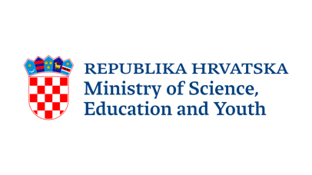

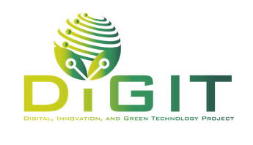


REPUBLIC OF CROATIA
MINISTRY OF SCIENCE, EDUCATION AND YOUTH
Donje Svetice 38, Zagreb 10 000, Croatia

DIGITAL, INNOVATION, AND GREEN TECHNOLOGY PROJECT
(DIGIT PROJECT)
IBRD LOAN NO. 9558-HR
PROJECT ID: P180755

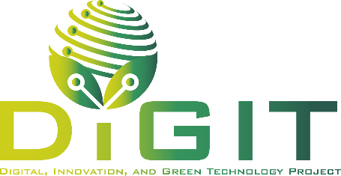

ANNEX III. DECLARATION BY THE PARTNER

CALL FOR PROPOSALS
VALIDATION OF SOCIAL INNOVATIONS BY STARTUPS (VALID)
CALL REFERENCE NUMBER: DIGIT.2.1.01

May 2026
Declaration by the Partner
Name of the Partner: | <Name of the enterprise/research organization>
Project title: | <Name of the project>

The partner, represented by the undersigned, being the authorized signatory of the partner, and in the context of the present application to the Call for proposals "Validation of Social Innovations by Startups (VALID)” (Call reference number: DIGIT.2.1.01) hereby declares that:
- The partner confirms that they have understood and accept all the terms and conditions of the Call for Proposals.
- All information and data provided in the application package are accurate, complete, and truthful. The partner confirms that they understand that any false or misleading information may result in the disqualification of the application and potential legal consequences.
- The partner confirms that the project does not constitute double funding.
- The partner confirms that project is implemented in Republic of Croatia.
- The partner, or their legal representatives, are not in any of the situations excluding them from participating in Call for proposals which are listed in the Section 1.1 of Annex I. Conditions for the preparation and implementation of projects within the DIGIT Project (hereafter: Annex I. of the Guidelines for Applicants).
- The partner will act in accordance with the principles of economy, efficiency and effectiveness.
- The partner <is/is not> subject to value-added tax (VAT) and <is/is not> registered in the VAT register based on supplies provided within the scope of their authority.
- The partner <can/cannot> claim a deduction for value-added tax. <The partner can claim deduction for value-added tax for:
- All cost items listed in this project proposal.
- The following cost items listed in this project proposal: (please specify the cost items for which you have the right to claim a VAT deduction).>
- The partner declares that they are not subject to recovery of funds as per the decision of the competent authority, including cases where a refund has been requested due to previously received aid being declared unlawful or incompatible with the applicable regulation;
- The implementation of the project has not started prior to the submission of the project proposal.
- At the time of submitting the project proposal, the project is not physically or financially completed, nor must the project be completed before the signing of the Grant Agreement.
- The project is ready for the start of the activities and their completion in accordance with the set timeframes.
- The partner is familiar with the objectives and guidelines related to ethical principles applicable to projects funded under the DIGIT Project. The project has been prepared in accordance with these ethical principles. We declare that throughout the implementation of the project, we will adhere to and apply all provisions stated in the Code of Ethics, which is published on the website of the Ministry of Science, Education, and Youth.
- The partner will deliver immediately, upon request, documentation that proves the eligibility conditions of the partner, as well as the project, and project activities and costs.
- The project is in accordance with Horizontal principles and Ethics as described in Annex I. of the Guidelines for Applicants.
- The partner agrees that the entire application documentation and data from the evaluation of project proposals may be used for the purpose of the evaluation of the Call for proposals, regardless of whether the partner receives support or not.
- The partner agrees to be contacted to participate in future surveys related to the Call for proposals, if the relevant authorities choose to conduct them, regardless of whether the partner receives support or not, and that the data collected from these surveys may be used for the purpose of evaluating the Call for proposals.
Conditions applicable to partner that is enterprise:
- The partner confirms that they are not in difficulty, as defined in Article 2, point 18 of Regulation (EU) No 651/2014).
Conditions applicable to partner that is research organization:
- The partner confirms that the funds allocated under this Call will not be used for economic activities.
- The partner confirms that they will separate economic and non-economic activities.
- The partner confirms that the economic activities consisting of offering products or services on a specific market do not exceed 20% of the total annual capacity of the research organization.
- The partner commits to submit financial reports showing the separate financing, costs, and revenues of economic and non-economic activities, if applicable, after the project implementation and until the depreciation period expires (only in case when equipment is purchased).
- The partner commits to submit capacity use reports after the project implementation and until the depreciation period expires (only in case when equipment is purchased).
The partner agrees that their personal data may be transferred to the competent authorities for further action, for the purposes of safeguarding the financial interests of the relevant authorities.

Signed on behalf of the Partner
Place and date:
Partner:
Name of the authorized signatory of the Partner:
Position:
Signature:

Code of Ethics, link

