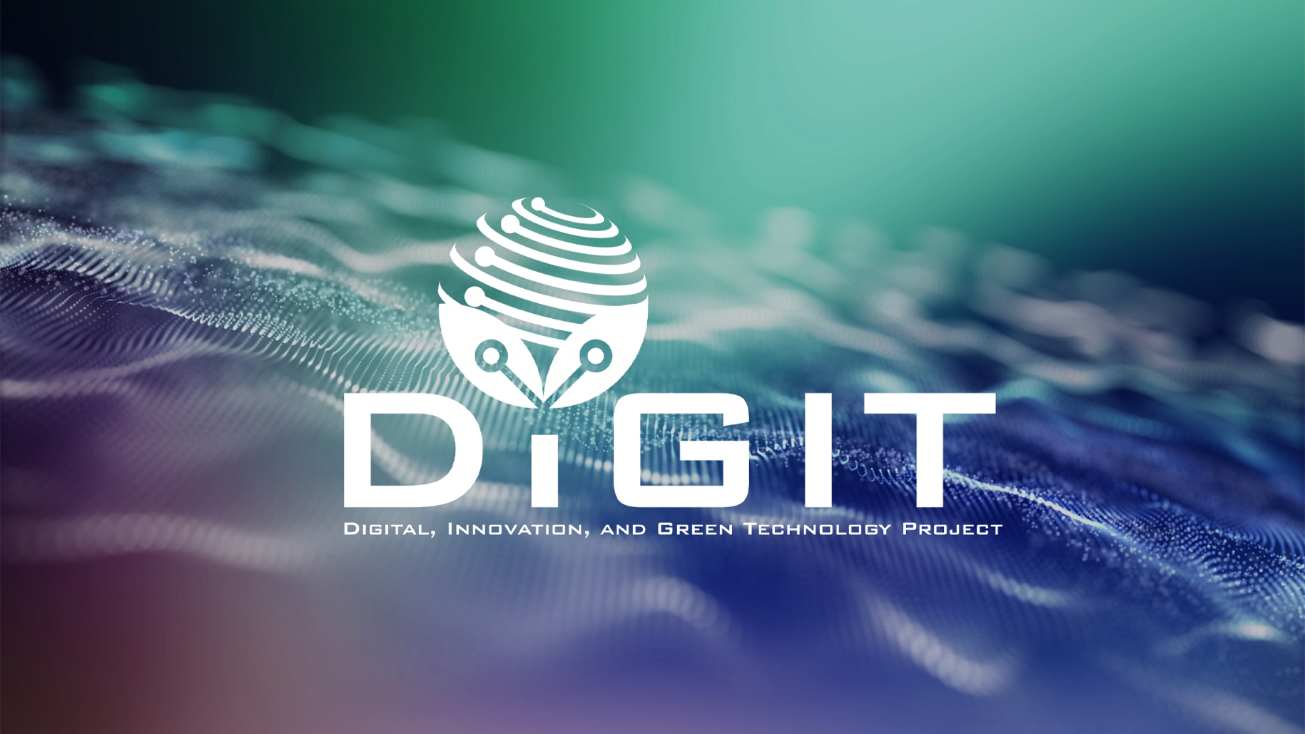

DIGITAL, INNOVATION, AND GREEN TECHNOLOGY PROJECT
(DIGIT PROJECT)

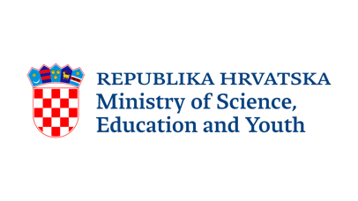

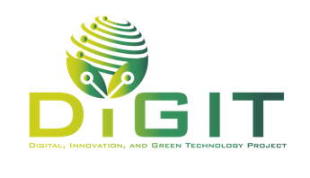


REPUBLIC OF CROATIA
MINISTRY OF SCIENCE, EDUCATION AND YOUTH
Donje Svetice 38, Zagreb 10 000, Croatia

DIGITAL, INNOVATION, AND GREEN TECHNOLOGY PROJECT
(DIGIT PROJECT)
IBRD LOAN NO. 9558-HR
PROJECT ID: P180755

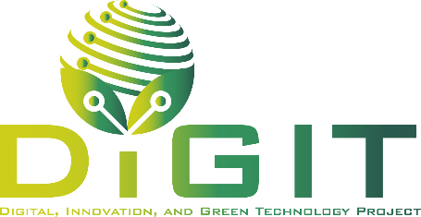

ANNEX XI. DECLARATION ON THE RECEIVED AID

CALL FOR PROPOSALS
VALIDATION OF SOCIAL INNOVATIONS BY STARTUPS (VALID)
CALL REFERENCE NUMBER: DIGIT.2.1.01

May 2026
Declaration on the received aid

Declaration on aid received for the beneficiary and individually for each undertaking considered a “Single Undertaking”
Name of the beneficiary: | <Name of the entity>
Project title: | <Name of the project>

Declaration on Granted State Aid and de minimis Aid*
Important: Please provide information on aid that has already been granted, as well as on aid applied for by the applicant/partner (if any) that is currently under assessment by other aid providers.
Name: | <Name of the entity>
Address: | <Address>

In the first preceding year** | Name of  de minimis aid provider | Amounts of aid (in EUR)**** | Dates of granting of aid*****  (enter N/A for aid for which the beneficiary/applicant/partner has applied)
In the second preceding year** | Name of  de minimis aid provider | Amounts of aid (in EUR)**** | Dates of granting of aid*****  (enter N/A for aid for which the beneficiary/applicant/partner has applied)
In the third preceding year** | Name of  de minimis aid provider | Amounts of aid (in EUR)**** | Dates of granting of aid*****  (enter N/A for aid for which the beneficiary/applicant/partner has applied)

Name of state aid provider | Type of aid*** | Costs for which the state aid was granted | Amounts of state aid (EUR)**** | Dates of granting of aid*****  (enter N/A for aid for which the beneficiary/applicant/partner has applied)

* It is necessary to indicate de minimis aid and state aid received by the applicant and all linked undertakings.
Projects financed from funds that do not constitute state aid (such as Horizon 2020 and other Union Programmes) should not be included in this declaration.
The declaration must be signed by the authorised representative of the applicant.
** Refers to a rolling three-year period from the date of submission of the form for the applicant and linked undertakings (if applicable) in relation to de minimis aid (e.g. if the form is submitted on 30 April 2026, the relevant three-year period covers 30 April 2023 to 30 April 2026).
*** State aid (regional and other), subsidised loans, guarantees, tax exemptions, etc.
**** If the aid was received in HRK, it should be converted at the Croatian National Bank middle exchange rate applicable on the date of granting.
***** Aid is considered granted at the moment when the undertaking acquires the legal right to receive it in accordance with the applicable national legal framework, regardless of the date of actual payment.

We declare that we have fulfilled all contractual obligations related to the aid received as listed in the above table.
Under criminal and material liability, we declare that all information provided in this Declaration is true, accurate, and complete.

Place and date:
Declarant:
Name of the authorized signatory of the Declarant:
Position:
Signature:

