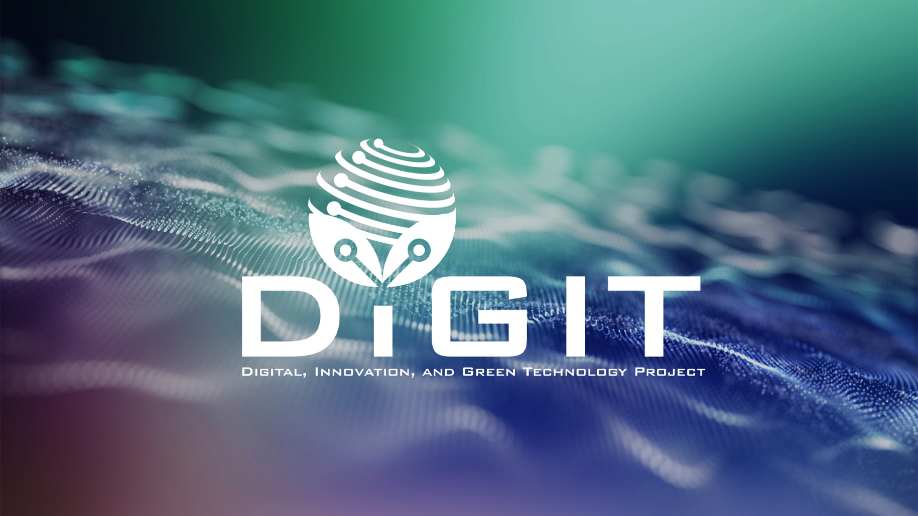

DIGITAL, INNOVATION, AND GREEN TECHNOLOGY PROJECT
(DIGIT PROJECT)



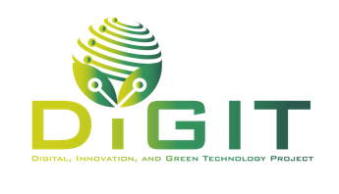


REPUBLIC OF CROATIA
MINISTRY OF SCIENCE, EDUCATION AND YOUTH
Donje Svetice 38, Zagreb 10 000, Croatia

DIGITAL, INNOVATION, AND GREEN TECHNOLOGY PROJECT
(DIGIT PROJECT)
IBRD LOAN NO. 9558-HR
PROJECT ID: P180755

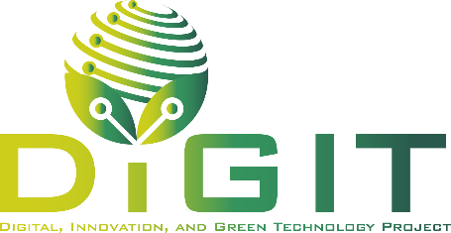

ANNEX X. DECLARATION BY THE COLLABORATOR

CALL FOR PROPOSALS
VALIDATION OF SOCIAL INNOVATIONS BY STARTUPS (VALID)

CALL REFERENCE NUMBER: DIGIT.2.1.01

May 2026
Declaration by the Collaborator
Name of the Collaborator: | <Name of the entity>
Project title: | <Name of the project>

The collaborator, represented by the undersigned, being the authorized signatory of the collaborator, and in the context of the present application to the Call for proposals “Validation of Social Innovations by Startups (VALID)” (Call reference number: DIGIT.2.1.01) hereby declares that:
- The collaborator has participated in the preparation and/or development of the above-mentioned project proposal, and is committed to participate in project implementation, in the form and to the extent described in the project proposal, in case the project proposal receives funding.
- The collaborator agrees to be contacted to participate in future surveys related to the Call for proposals, if the relevant authorities choose to conduct them, regardless of whether the project receives support or not, and that the data collected from these surveys may be used for the purpose of evaluating the Call for proposals.
The collaborator agrees that their personal data may be transferred to the competent authorities for further action, for the purposes of safeguarding the financial interests of the relevant authorities.

Signed on behalf of the Collaborator

Place and date:
Applicant:
Name of the authorized signatory of the Collaborator:
Position:
Signature:

