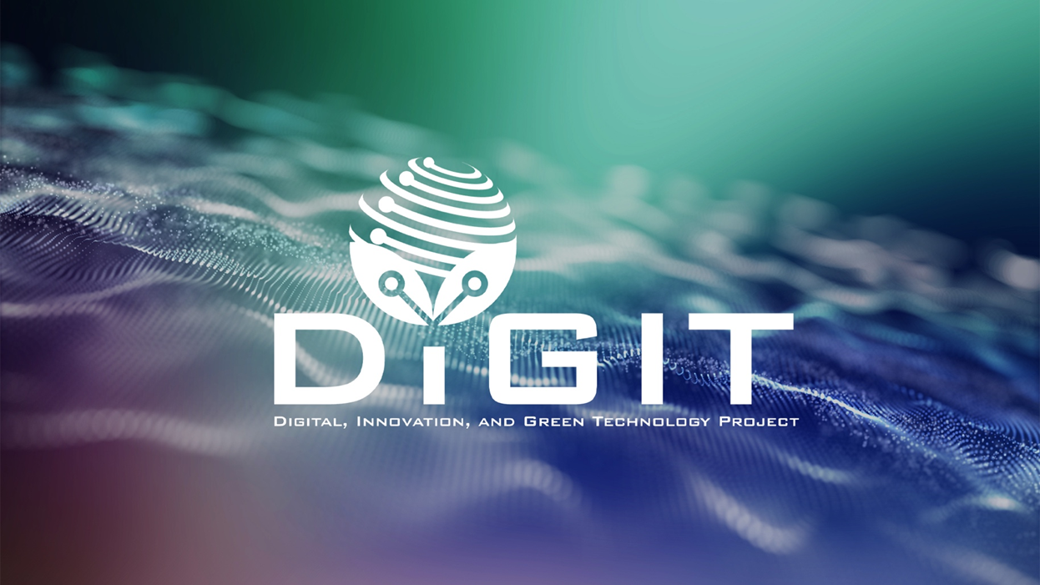

DIGITAL, INNOVATION, AND GREEN TECHNOLOGY PROJECT
(DIGIT PROJECT)



REPUBLIC OF CROATIA
MINISTRY OF SCIENCE, EDUCATION AND YOUTH
Donje Svetice 38, Zagreb 10 000, Croatia

DIGITAL, INNOVATION, AND GREEN TECHNOLOGY PROJECT
(DIGIT PROJECT)
IBRD LOAN NO. 9558-HR
PROJECT ID: P180755



ANNEX VIII. DECLARATION BY THE TECHNLOGY SCOUT
CALL FOR PROPOSALS UNDER THE
TECHNOLOGY SCOUTING PROGRAM
CALL REFERENCE NUMBER: DIGIT.1.2.02

April 2026
Declaration of Involvement
I, the undersigned, [Name and surname], holder of OIB/Personal Identification Number [insert number], acting as a Technology Scout certified under the DIGIT Project, hereby declare that I have been engaged in activities related to the project proposal titled:
"[Insert full project title]"
submitted to Call for proposals under the Technology Scouting Program DIGIT.1.2.02
I confirm that I have actively participated in the preparation and/or development of the above-mentioned project proposal, in line with my role and responsibilities as a Technology Scout, and that my involvement pertains to the scope of services foreseen under the DIGIT Technology Scouting Program.
This declaration is made truthfully and in good faith for the purpose of confirming my professional engagement in the project proposal.
Place:
_______________________
Date:
_______________________
Name and surname:
_______________________

Signature:
_______________________

