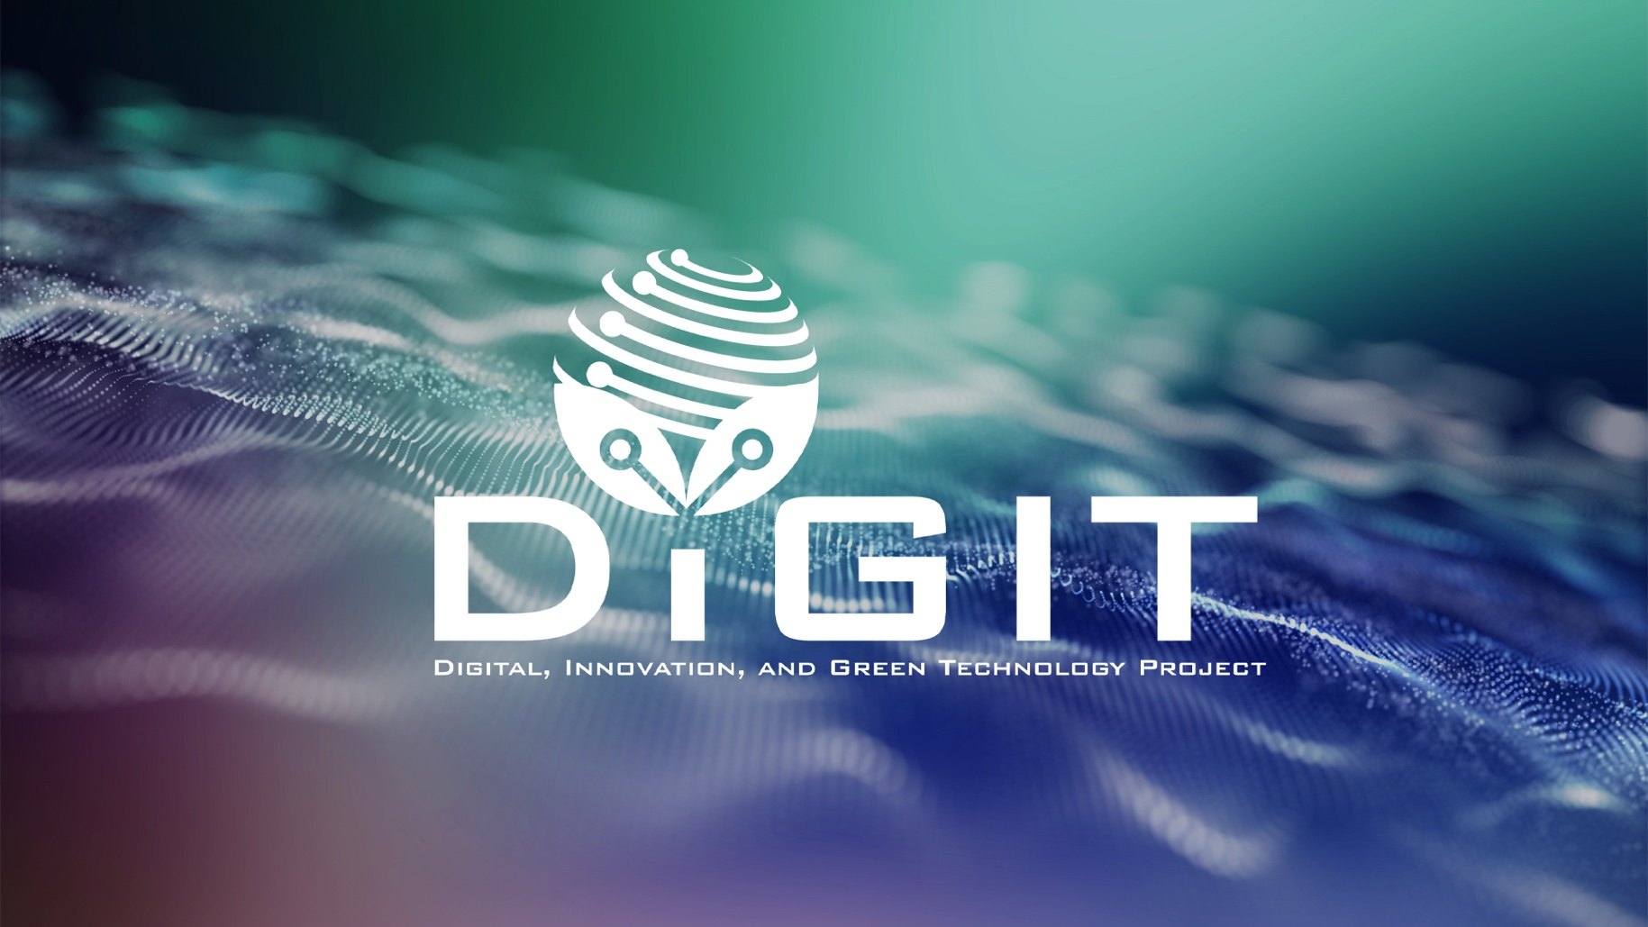

DIGITAL, INNOVATION, AND GREEN TECHNOLOGY PROJECT
(DIGIT PROJECT)





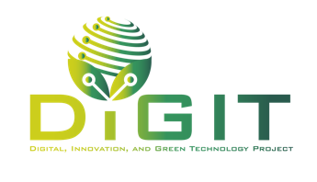

REPUBLIC OF CROATIA
MINISTRY OF SCIENCE, EDUCATION AND YOUTH
Donje Svetice 38, Zagreb 10 000, Croatia

DIGITAL, INNOVATION, AND GREEN TECHNOLOGY PROJECT
(DIGIT PROJECT)
IBRD LOAN NO. 9558-HR
PROJECT ID: P180755



GUIDELINES FOR APPLICANTS
CALL FOR PROPOSALS UNDER THE
“TECHNOLOGY SCOUTING PROGRAM”

CALL REFERENCE NUMBER: DIGIT.1.2.02

April 2026
Guidelines for contractual research agreements
Note: A research contract concluded between the applicant and research organization in this Call must follow content guidelines and meet minimum requirements given below. These contracts will be subject to control during project implementation.
When establishing a contractual research agreement between a company (client) and a research organization (service provider), both parties should ensure that the contract clearly defines their respective rights, obligations, ownership, and responsibilities.
The contract agreement should include at least the following key elements:
1. Scope and objectives of research
- Clearly define the research objectives, expected outcomes, and scope of work to be performed.
- Specify measurable deliverables, timelines, and performance indicators.
- Clarify that the research organization performs the work on behalf of the company and in accordance with the defined technical specifications.
2. Roles, responsibilities, and communication
- The company provides the research brief, relevant background information, and materials necessary for implementation.
- The research organization performs the research using its own expertise, infrastructure, and personnel.
- Define the communication channels, reporting procedures, and approval process for interim and final results.
3. Financial terms
- Define the total contract value, payment schedule, and invoicing conditions.
- Include provisions on eligible costs, possible budget adjustments, and payment linked to deliverables.
4. Risk management
- Include provisions for risk sharing among the partners.
5. Intellectual property (IP) management (if applicable)
- Provide information on the terms and management of intellectual property rights.
- Specify provisions regarding:
  - Background IP: Intellectual property brought into the project by any contract party.
  - Foreground IP: Intellectual property created during the project.
- Ownership and usage rights for IP resulting from the project, including licensing and sharing provisions.
6. Confidentiality and data protection
- Include a non-disclosure clause protecting all confidential and proprietary information shared during the project.
- Specify the duration of confidentiality obligations (commonly 3-5 years after project completion).
- Ensure compliance with relevant data protection laws (e.g. GDPR).
7. Technology transfer and use of results
- Define how results may be used, licensed, or commercialized after project completion.
- If the company intends to transfer or sublicense results, include terms for acknowledging the research organization or ensuring continued access to knowledge.
- Optionally, include provisions for follow-up collaboration or participation in further R&D projects.
8. Non-compliance
- Define the provisions in case of failure to fulfill obligations by any party.
9. Data access and protection
- Specify the provisions related to data access and the protection of personal data.
10. Mutual liability and guarantees
- Include provisions for mutual liability and guarantees among the parties.
11. Liability for damage
- Define responsibility for damage caused to third parties.
12. Use of background information and confidential information
- Address the use of background information, protection of confidential information, and public dissemination of project results.
13. Public disclosure and visibility
- Include provisions on public communication of the project’s results, ensuring public awareness and visibility.
14. Force majeure
- Define the procedures and obligations in case of force majeure events.
15. Applicable law and dispute resolution
- Specify the applicable law and mechanisms for resolving disputes.

