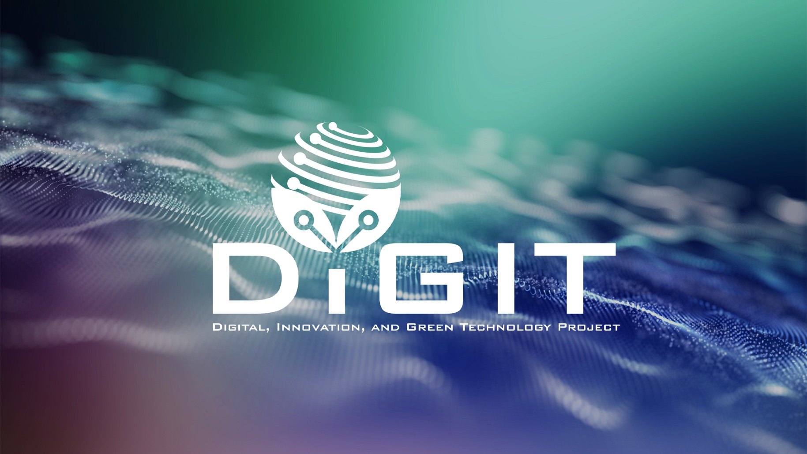

DIGITAL, INNOVATION, AND GREEN TECHNOLOGY PROJECT
(DIGIT PROJECT)





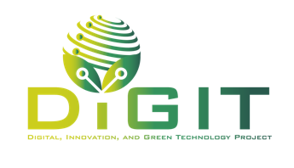

REPUBLIC OF CROATIA
MINISTRY OF SCIENCE, EDUCATION AND YOUTH
Donje Svetice 38, Zagreb 10 000, Croatia

DIGITAL, INNOVATION, AND GREEN TECHNOLOGY PROJECT
(DIGIT PROJECT)
IBRD LOAN NO. 9558-HR
PROJECT ID: P180755



GUIDELINES FOR APPLICANTS
CALL FOR PROPOSALS UNDER THE
“TECHNOLOGY SCOUTING PROGRAM”

CALL REFERENCE NUMBER: DIGIT.1.2.02

April 2026

Application form
Note: This application form should be completed through the eDIGIT portal. All project proposals must be submitted electronically through the designated portal. The provided application form is indicative and is intended to guide applicants on the expected format and structure. Applicants should carefully follow this format to ensure all necessary information is included.

Project overview
Project Information
Project title: | <Name of the project>
Name of the Applicant: | <Name of the organization>
Predominant scientific area of the project proposal (1)
Predominant scientific field of the project proposal (1)
Secondary scientific areas of the project proposal (if applicable)
Predominant S3 thematic priority area (1)
Secondary S3 thematic areas (if applicable)
(section) (NACE rev. 2.1)
Predominant activity (class) (if applicable)
Please indicate whether the project includes women among any of the following: firm owner, CEO, research team lead) | <Yes>  <No>
Keywords related to the project proposal (max. 200 characters) | Provide a concise list of keywords that best describe key project elements, such as the innovative solution, its intended application, sectoral relevance, technological domain, or other relevant aspects.
Project duration: | <Number of months (maximum 12 months)>
Total project budget: | <Total project budget in euros>
Project objectives: | <Overall objective(s) and Impact indicator(s)>  <Specific objective(s) and Outcome indicator(s)>
Expected outputs: | <List the main expected outputs from the project>
Project activities: | <List the main activities planned under the project>
Target group(s): | <List the main target groups/entities who will directly benefit from the project>
Location of the project:
Project summary (max. 750 characters, including spaces) | <Provide a concise description of the project, clearly explaining the main problem or challenge addressed, the proposed solution, and the key results and objectives to be achieved. The summary should highlight the relevance of the project.>

Applicant Information
Please fill in the fields in the table with information about the project applicant.
Information about the Applicant
Name of the Applicant
Size of enterprise | <Micro>  <Small>  <Medium>
Personal identification number
Street and house number
Municipality/City
Zip code
Country
Type of contracting authority according to the Law of Public Procurement | <Public contracting authority>  <Sectoral contracting authority>  <Not applicable>
Phone/cell phone number
E-mail address
Web page
Responsible person
Function
Personal identification number
Gender | <Female>  <Male>  <Other>
Phone/cell phone number
Responsible person’s e-mail
Contact person for this project
Function
Personal identification number
Phone/cell phone number
Contact person’s e-mail

Declaration of previously awarded grants for innovation advisory and support services

Please enter information about grants awarded to the applicant, which relate to costs defined under Article 28, paragraph 2(c) of the General Block Exemption Regulation, namely “costs for innovation advisory services and innovation support services, including services provided by research and knowledge dissemination organizations, research infrastructures, testing and experimentation infrastructures, or innovation clusters.”
‘Innovation advisory services’ means consultancy, assistance or training in the fields of knowledge transfer, acquisition, protection or exploitation of intangible assets or the use of standards and regulations embedding them, as well as consultancy, assistance or training on the introduction or use of innovative technologies and solutions (including digital technologies and solutions).
‘Innovation support services’ means the provision of office space, data banks, cloud and data storage services, libraries, market research, laboratories, quality labelling, testing, experimentation and certification or other related services, including those services provided by research and knowledge dissemination organizations, research infrastructures, testing and experimentation infrastructures or innovation clusters, for the purpose of developing more effective or technologically advanced products, processes or services, including the implementation of innovative technologies and solutions (including digital technologies and solutions).
Please list all grants awarded for the listed purposes in the current year (year n), and the three calendar years preceding it (years n-1, n-2, and n-3). If you received no grants that included aid for innovation advisory services and innovation support services, leave blank.

Name of aid provider | Type of aid | Date of aid award | Aid amount in EUR
 | <Innovation Aid for SMEs>
 | <Innovation Aid for SMEs>
 | <Innovation Aid for SMEs>
TOTAL:

Information about the Technology Scout

Information about the Technology Scout
Name and Surname
Personal identification number
Street and house number
Municipality/City
Zip code
Country
Type of contracting: | <service contract, contract for work, business cooperation agreements >
Phone/cell phone number
E-mail address

Abstract
Abstract of the Project (max 5,000 characters with spaces)
<Provide a concise summary of your project, outlining its objectives, the target group(s) it aims to benefit. Include the activities, expected results and impact of the project.>

Project excellence
  - Innovation challenge
Innovation challenge (max 5,000 characters with spaces)
<Clearly describe the innovation challenge you aim to address with the proposed project. Explain how the challenge was identified through cooperation with the technology scout. Define what problem or opportunity it represents for your company or sector. Include the context and motivation (what gap or limitation project proposal addresses), the scientific, technological, and/ or industrial background, the objectives of the proposed research, the relevance of the challenge for your company’s development strategy. Clearly indicate the extent to which the application suggests exploring the proof of concept. Specify and explain the Technology Readiness Level.>

  - Scientific and technological soundness
Scientific and technological soundness (max 5,000 characters with spaces)
<Clearly describe the scientific and technical concept of your project and explain how it addresses the identified innovation challenge. Define the specific technical or scientific problems you aim to solve and demonstrate why the proposed level of innovation is appropriate for TRL 3-4. Present clear objectives and methods, and explain how the research expertise and contractual research activities will contribute to validating the concept. Describe how collaboration between the company and the research organization will be organized to ensure a realistic, evidence-based approach.>

Project potential
  - Market validation and business feasibility
Market validation and business feasibility(max 5,000 characters with spaces)
<Clearly describe the market need your project addresses and explain who experiences the problem, how it is currently handled, and why your proposed concept offers an improvement. Identify the target users and present preliminary but credible evidence demonstrating that the need is real and relevant. Provide a concise analysis of the market context, indicative demand, and potential application areas.
Focus on demonstrating early feasibility and relevance, not full commercialization readiness. Explain the potential future market pathway and justify how the proposed research is linked to the identified need using simple, evidence-based reasoning.>

  - Impact, scalability and sustainability
Impact, scalability and sustainability (max 10,000 characters with spaces)
<Explain how the proposed technology, product, or service could evolve, reach higher TRLs, or be applied to new markets and sectors. Describe whether the project has the potential to generate new intellectual property (IP), proprietary know-how, or other forms of competitive advantage, and outline how these results will be managed and utilized.
Provide a sustainability and scalability plan indicating how the company intends to maintain, expand, or build upon the project outcomes beyond its duration - for example, through integration into production processes, follow-up R&D, commercialization, or partnerships and investments.
Describe the expected benefits for end-users, the economy, or the wider society, including potential environmental or social impacts aligned with green and digital transition goals. Explain how the collaboration with research partners could strengthen the company’s long-term innovation capacity and contribute to the creation of sustainable value and future growth.>

Project feasibility
  - Technological feasibility
Technological feasibility (max 10,000 characters with spaces)
< Explain how your idea and concept will be tested and validated within the scope of the project. Demonstrate that the planned research activities are sufficiently detailed and logically structured to verify the innovative concept at TRL 3-4 through experimental work in a controlled laboratory environment.
Describe the infrastructure, equipment, and expertise that will be used, and justify that these resources are adequate to perform the planned tests. Outline a clear sequence of activities showing how the project will progress from the identified innovation challenge to the proof-of-concept demonstration.
You should also show that the budget and resources are realistic and proportionate to the planned activities, confirming that the feasibility of the idea can be credibly demonstrated within the project timeframe.>

  - Implementation, relationship and risk management
Implementation, relationship and risk management (max 5,000 characters with spaces)
< Clearly describe how the project will be implemented, including the roles, responsibilities, and coordination mechanisms between the company and the research organization. Explain how collaboration will be managed and supported to ensure effective communication, decision-making, and problem-solving throughout the project. Outline the procedures for project monitoring, reporting, and ensuring timely progress towards objectives. Include a clear risk management plan that identifies potential technical, operational, and coordination risks and describes appropriate mitigation measures to monitor, address, and prevent these risks in order to keep the project objectives on track.>

    - Project team members
Project team members
This table should include all individuals included in project activities. If the project foresees the employment of new personnel, these positions must also be listed in the table and clearly marked as: planned new employment. For new employees, Surname, Name and Gender should be indicated as N/A. The role in the project team, role type, and planned FTE engagement must still be specified.
Employment status [Existing staff / Planned new employment] | Surname | Name | Gender | Name of the organization | Role in project team | Role type  [Leading] or [Team member] | Planned FTE engagement (%)
…
…
…
…

    - Risk and mitigation
Risk and mitigation
<Describe any critical risks related to project implementation that may prevent the stated project's objectives from being achieved.
Detail any risk mitigation measures that will be put in place. Provide a table with critical risks identified and the corresponding mitigating actions. Describe the role of Technology Scout in risk mitigation.>
Defined risk (external and internal) | Description | Likelihood of their occurrence (low/medium/high) | Impact (low/medium/high) | Risk mitigation measures
…
…
…

Project activities
Implementation start date

Duration of implementation (months)

Name of the activity | Start month of activity implementation | Last of activity implementation | Description of the activity
…
…
…

Outcome and output indicators
  - Objectives

When setting outcome and output indicators and target values, please take into account the requirements in the Theory of Change within Guidelines for Applicants. Add additional rows in the table below if needed, depending on the number of planned project impact, outcome and output indicators.
Indicator name | Level (impact, output or outcome) | Target value | Deadline for achievement | Reporting frequency | Rationale for achievement
<Impact>
<Outcome>
<Output>
<Impact>
<Outcome>
<Output>
<Impact>
<Outcome>
<Output>

Budget

Please copy and fill a table detailing costs for each project activity. The following funding categories are available (drop-down menu):
- Micro, small or medium-sized enterprise – Aid for R&D
- Micro, small or medium-sized enterprise – Innovation Aid
Please ensure that the selected funding category correctly corresponds to each project activity and cost, as specified in the Guidelines for Applicants (GfA), as well as to the size of the enterprise implementing that activity.

[activity 1]
Cost name | Cost category | Cost-responsible entity | Funding category | Number of units | Unit cost | Total | Description
cost 1 – Technology scout | <Other direct costs> |  | <Micro, or small enterprise – Innovation Aid for SMEs>  <Medium-sized enterprise - Innovation Aid for SMEs>  <Micro, or small enterprise - Aid for R&D>  <Medium-sized enterprise - Aid for R&D>

[activity 2]

Cost name | Cost category | Cost-responsible entity | Funding category | Number of units | Unit cost | Total | Description
[cost 1] | <Direct costs – personnel>  <Other direct costs> |  | <Micro, or small enterprise – Innovation Aid for SMEs>  <Medium-sized enterprise - Innovation Aid for SMEs>  <Micro, or small enterprise - Aid for R&D>  <Medium-sized enterprise - Aid for R&D>
[cost 2]
[cost 3]
…
[activity 3]
Cost name | Cost category | Cost-responsible entity | Funding category | Number of units | Unit cost | Total | Description
[cost 1] | <Other direct costs> |  | <Micro, or small enterprise – Innovation Aid for SMEs>  <Medium-sized enterprise - Innovation Aid for SMEs>  <Micro, or small enterprise - Aid for R&D>  <Medium-sized enterprise - Aid for R&D>
[cost 2]
[cost 3]
…

[activity 4]
Cost name | Cost category | Cost-responsible entity | Funding category | Number of units | Unit cost | Total | Description
[cost 1] – 7% of total eligible costs under the Activity 2 | <Project management costs,  Publicity and visibility costs,  Other administrative costs related to management, accounting, cleaning, telephone, water or electricity services and other similar costs.> |  | <Micro, or small enterprise - Aid for R&D>  <Medium-sized enterprise - Aid for R&D>  <Micro, or small enterprise - Aid for R&D>  <Medium-sized enterprise - Aid for R&D>

Budget summary
Please ensure that the data entered in this section corresponds to data from the previous section and the data in this form.
  - Total value of the project (EUR)
Total value of the project | Total eligible costs | Total grant funds | Total ineligible costs
  - Sources of funding (EUR)
Applicants are required to select all applicable funding categories and, for each type of aid, indicate the total eligible costs, the support intensity, the amount of grant funds, and the applicant’s own contribution.
Funding category | Total eligible costs | Support intensity | Grant funds | Applicant’s own funds
Micro or small enterprise Aid for R&D
Medium-sized enterprise – Aid for R&D
Micro or small enterprise – Innovation Aid for SMEs
Medium-sized enterprise – Innovation Aid for SMEs
TOTAL
- Horizontal principles and ethical compliance
In this section, describe the contribution to horizontal principles and compliance with ethics standards.
  - Horizontal principles
Horizontal principles (max 4,000 characters with spaces)
<Applicants must comply with legal requirements related to horizontal policies, which is the minimum standard for eligibility. To promote horizontal policies effectively, projects should go beyond mere compliance by actively contributing to sustainable development, equal opportunities and non-discrimination, and gender equality. Projects that demonstrate additional activities in these areas will be more favorably evaluated, whereas projects with negative impacts on these principles will not be approved.>

  - Ethical compliance
Ethical compliance (max 4,000 characters with spaces)
<Describe how your project complies with the DIGIT Project's Code of Ethics. Ensure you address each ethical principle, such as honesty, integrity, transparency, and social responsibility, and explain the measures your project will take to uphold these standards during implementation. Highlight any specific actions or safeguards you will use to prevent ethical breaches, including compliance with open access requirements for publications and data. Confirm that you understand the requirements for establishing a Grievance Redress Mechanism (GRM) and describe in detail how you will set up this mechanism. Include specifics such as the contact details (e.g., an e-mail address) for receiving public complaints or suggestions, how this information will be publicly communicated, and how you will manage and report received grievances to the DIGIT Project GRM. Ensure your GRM includes measures for recording, processing, and responding to all feedback effectively.>

Attachments
Attachments
Declaration by the Applicant (pdf)
Group statement (pdf)
CVs of team members (.zip or .pdf)
Declaration by the Technology Scout (pdf)

Sector refers to first level of classification (e.g., C - Manufacturing)
NACE Rev.2.1, link, DZS, link
Activity refers to fourth level of classification (e.g., 27.11 - Manufacture of electric motors, generators and transformers)

