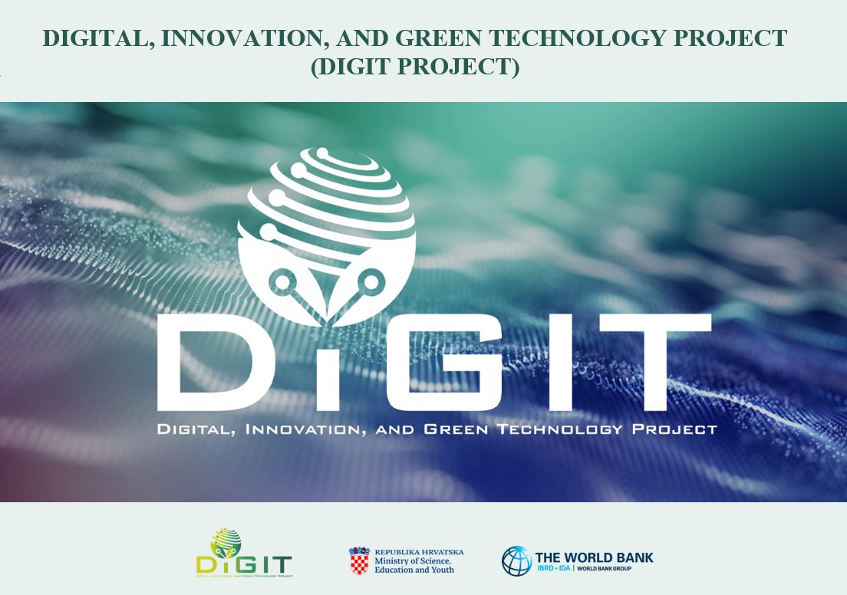

**REPUBLIC OF CROATIA**

**MINISTRY OF SCIENCE, EDUCATION AND YOUTH**

Donje Svetice 38, Zagreb 10 000, Croatia

**DIGITAL, INNOVATION, AND GREEN TECHNOLOGY PROJECT (DIGIT PROJECT)**

IBRD LOAN NO. 9558-HR

PROJECT ID: P180755

**REPUBLIC OF CROATIA**

**MINISTRY OF SCIENCE, EDUCATION AND YOUTH**

Donje Svetice 38, Zagreb 10 000, Croatia

**DIGITAL, INNOVATION, AND GREEN TECHNOLOGY PROJECT (DIGIT PROJECT)**

IBRD LOAN NO. 9558-HR

PROJECT ID: P180755



**ANNEX VII. ENVIRONMENTAL AND SOCIAL SCREENING QUESTIONNAIRE**

**CALL FOR PROPOSALS “ROUTES TO SYNERGIES”**

CALL REFERENCE NUMBER: DIGIT.2.2.02

April 2025

**ENVIRONMENTAL AND SOCIAL SCREENING QUESTIONNAIRE (SIMPLIFIED)**

Note: The applicant is not required to sumbit the Environmental and Social Screening Questionnaire (ESSQ) during the initial project proposal submission. If a project successfully passes the administrative and eligibility checks, the applicant will then be requested to complete and submit the ESSQ to provide additional details about the project and its activities. This request will specify a timeframe within which the completed ESSQ must be submitted.

If needed, this form is to be used by the applicant to screen for the potential environmental and social risks and impacts of a proposed project. It will assist the MSEY/PIU E&S specialists in establishing an appropriate E&S risk rating for these projects and specifying the type of environmental and social assessment required, including specific instruments/plans. The use of this form will allow the MSEY/PIU E&S specialists to form an initial view of the potential risks and impacts of a project. ***It is not a substitute for project-specific E&S assessments or specific mitigation plans.***

|  |  |
| --- | --- |
| **Name of the project:** |  |
| **Name of the Applicant:** |  |
| **Estimated investment:** |  |
| **Start/Completion date:** |  |
| **Brief description of the project activities (describe project features and location, type of research):**  *Annexes for all additional information can be supplemented if necessary (for example MSDS (Material Safety Data Sheet) of hazardous substances and materials)* |  |
| **Summary of Environmental and Social risks**  *(applicant’s self assessment):* |  |

### 1. ENVIRONMENTAL AND SOCIAL SCREENING QUESTIONNAIRE

| No. | Screening Questionnaire | Yes | No | Not known | Not applicable | Additional Clarifications |
| --- | --- | --- | --- | --- | --- | --- |
|  | Is the project listed in the WB exclusion list (section 1.2. Ineligible activities of the Annex I. Conditions for the preparation and implementation of projects within the DIGIT Project, or at the link: https://www.ifc.org/content/dam/ifc/doc/mgrt-pub/ifc-exclusion-list.pdf? |  |  |  |  |  |
|  | Will the implementation of project activities include generation of hazardous waste (for example hazardous medical waste, radioactive waste, e-waste..)? |  |  |  |  | *(if YES, specify what types of waste are generated and describe activities that generate those type of waste, describe waste management system in place/ planned for those types of waste and how the principles of circular economy are taken into account)* |
|  | Does the implementation of project activities include the generation of significant amount of non- hazardous waste? |  |  |  |  | *(if YES, specify what types of waste are generated and describe activities that generate those types of waste, describe waste management system in place/ planned for those types of waste and how the principles of circular economy are taken into account)* |
|  | Will the implementation of the project activities use hazardous substances[1] and materials (including radioactive materials)? |  |  |  |  | *(if YES, specify which hazardous substance /material is used and in which activity)* |
|  | Will there be procurement of equipment containing hazardous substances? (electrical and electronic equipment for research, medicine, biomedicine, etc)? |  |  |  |  | *(if YES, specify which equipment)* |
|  | Is the procurement of equipment that emits ionizing radiation planned? |  |  |  |  | *(if YES, specify which equipment)* |
|  | Is research on human or animal tissues planned? |  |  |  |  | *(if YES, describe in more detail)* |
|  | Will the planned project activities include laboratory research (for example biochemical laboratory, chemical, IT lab, medical laboratories, pharmaceutical, etc.)? |  |  |  |  | *(if YES, describe what type of research and laboratories)* |
|  | Is research on pathogenic organisms planned as part of the implementation of project activities? |  |  |  |  | *(if YES, describe in more detail)* |
|  | Will the planned project activities include laboratory research in biosafety laboratories? |  |  |  |  | *(if YES, specify which level of biosafety lab and describe research in more detail)?* |
|  | Will the project activities produce emissions to air (e.g. dust, air pollutants, greenhouse gas emissions, etc.)? |  |  |  |  | *(if YES, describe in more detail)?* |
|  | Is research/sampling from areas protected by the Nature Protection Act planned as part of the implementation of project activities?[2] |  |  |  |  | *(if YES, specify the protected area and describe the research in more detail. If permission / confirmation regarding interventions in protected areas has been obtained from the competent authority, please attach it in the Annex.)* |
|  | Is research planned in the area of ecological network?[3] |  |  |  |  | *(if YES, name the area. If preliminary assessment of acceptability for the ecological network area has been obtained from the competent authority, please attach it in the Annex.)* |
|  | Is research on protected plant and animal species planned as part of the implementation of project activities? |  |  |  |  | *(if YES, specify which species and describe the research in more detail)* |
|  | Is the activity likely to negatively impact biodiversity or sensitive natural areas? |  |  |  |  | *If YES, please elaborate.* |
|  | Is the activity likely to negatively impact environmental components: air quality (indoors, outdoors), water quality (surface and groundwater), soil, etc.? |  |  |  |  | *If YES, please elaborate.* |
|  | Is the activity associated with risks to cultural heritage? |  |  |  |  |  |
|  | Does the activity include any kind of civil works or installation works? |  |  |  |  | *If YES, please elaborate.* |
|  | Are there notable occupational health and safety (OHS) risks related to any of the project phases (including risks for pregnant employees, etc.)? |  |  |  |  | *If YES, please elaborate.* |
|  | Are there considerable community health and safety (CHS) risks related to any of the project phases? |  |  |  |  | *If YES, please elaborate.* |
|  | Are there any considerable risks for environment or human health related to the post-funding phase?. |  |  |  |  | *If YES, please elaborate* |
|  | Does the project require Environmental Impact Assessment (EIA)/Screening on the need for EIA?[4] |  |  |  |  | *(If YES, has the study/elaboration been completed? If so, please attach the opinion/decision from the Ministry in charge of environmental protection in the annex, confirming that the project is environmentally acceptable or stating that an EIA is not required.)* |
|  | Do the project /research activities include devices, data centres, networks etc. which require significant energy consumption? |  |  |  |  | *(if YES, please specify and describe energy consumption and the measures that are or will be in place in order to improve energy efficiency)* |
|  | Do the project /research activities include devices, data centres, networks, cooling/heating etc. which require significant water consumption? |  |  |  |  | *(if YES, please specify and describe water consumption and measures that are or will be in place in order to improve water use efficiency)* |
|  | Have the potential social impacts of the project results been considered? What impacts have been identified? |  |  |  |  | *(If YES, specify the social impacts associated with each project result: e.g., project/research activities require the collection and transfer of personal information and data; project/research activities will obtain consent prior to data collection; project/research activities require direct engagement and/or interaction with vulnerable groups (e.g., children, low-income households, people with disabilities, the elderly), etc.)* |
|  | Please list the potential stakeholders based on direct and indirect social impacts. |  |  |  |  |  |
|  | Have the stakeholders (especially those under potential direct impact) been informed and engaged in the process of defining the project? |  |  |  |  | *(if YES, list the stakeholders)* |
|  | Please explain the method(s) of information dissemination which has been used in the process of informing the stakeholders. |  |  |  |  |  |
|  | Please explain the method(s) of stakeholder engagement which has been used. |  |  |  |  |  |
|  | Has the project reached the consent of the stakeholders related to its definition, considering the potential social impacts? |  |  |  |  |  |
|  | Is any field work planned as part of the project activities? |  |  |  |  | *(If YES, please specify the type, location, and purpose of the field work.)* |

**2. SCREENING REPORT (the applicant does not fill out, this is part of administrative and eligibility check)**

|  |  |  |  |  |  |
| --- | --- | --- | --- | --- | --- |
| **Categorization of the Risk** | **Low Risk** | **Low Risk** | **Moderate Risk** | **Substantial Risk** | **High Risk** |
| There is no need for the E&S instrument | The applicant needs to prepare: | The applicant needs to prepare: | The applicant needs to prepare: | The applicant needs to prepare: |
| / | ESCOP  ESMP Checklist | ESMP Checklist  ESMP | ESMP  EIA | EIA |
| Environmental impacts identified (short description and note on significance) |  |  |  |  |  |
| Social impacts identified (short description and note on significance): |  |  |  |  |  |
| Additional comments: |  |  |  | In case of substantial risk, project is not eligible for funding. | In case of high risk, project is not eligible for funding. |

1. Substances and materials that are explosive and/or flammable (gases, liquids and solids), toxic to people and animals, radioactive, oxidizing, corrosive, carcinogenic, teratogenic, hazardous to environment
2. https://bioportal.hr/gis/

   strict reserve, national park, special reserve, nature park, regional park, natural monument, significant landscape, forest park and monument of park architecture (strogi rezervat, nacionalni park, posebni rezervat, park prirode, regionalni park, spomenik prirode, značajni krajobraz, park-šuma te spomenik parkovne arhitekture)
3. <https://bioportal.hr/gis/>

   Ecological Network Natura 2000: Areas under the Habitats Directive and Areas under the Birds Directive (Područja prema Direktivi o staništima te Područja prema Direktivi o pticama)
4. If the project activity is listed in Annex I., II. or III. of Ordinance on environmental impact assessment (OG 61/14, 3/17) (Uredba o procjeni utjecaja na okoliš (NN 61/14, 3/17); Prilog I., II. ili III.)