**DIGITAL, INNOVATION, AND GREEN TECHNOLOGY PROJECT   
(DIGIT PROJECT)**



**REPUBLIC OF CROATIA**

**MINISTRY OF SCIENCE, EDUCATION AND YOUTH**

Donje Svetice 38, Zagreb 10 000, Croatia

**DIGITAL, INNOVATION, AND GREEN TECHNOLOGY PROJECT (DIGIT PROJECT)**

IBRD LOAN NO. 9558-HR

PROJECT ID: P180755

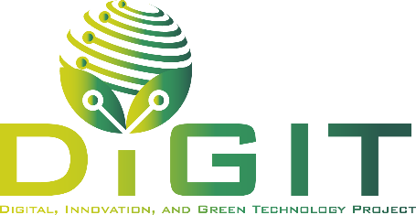

**ANNEX VI. MINIMUM CONTENT REQUIREMENTS FOR THE PARTNERSHIP AGREEMENT**

**CALL FOR PROPOSALS**

**“ROUTES TO SYNERGIES”**

CALL REFERENCE NUMBER: DIGIT.2.2.02

April 2025

## **Minimum content requirements for the Partnership Agreement**

**Note: At the request of the CSF, a Partnership agreement concluded between the applicant and partner for this Call must be submitted before adopting an Award decision on funding and signing of the Grant Agreement. It is not required during the application submission stage.**

The Partnership agreement, to be concluded between the applicant and partner, must include the following mandatory provisions:

**1. General information, purpose and objective of the partnership**

* Provide information about the project and the call for proposals name and reference numbers. Clearly define the purpose and objectives of the collaboration or partnership.

**2. Roles and responsibilities**

* Details about the roles and responsibilities of all parties involved in the agreement, including the tasks and obligations of the applicant and partner in the implementation of project activities.

**3. Decision-making process**

* Outline the decision-making procedures at the consortium level, including provisions for amendments, termination, and transfer of the agreement.

**4. Risk management**

* Include provisions for risk sharing among the partners.

**5. Intellectual property (IP) management (if applicable)**

* Provide information on the terms of collaboration and management of intellectual property rights.
* Specify provisions regarding:
  + Background IP: Intellectual property brought into the project by any consortium member.
  + Foreground IP: Intellectual property created during the project.
* Ownership and usage rights for IP resulting from the project, including licensing and sharing provisions.

**6. Communication and information transfer**

* Outline the methods of communication and information transfer within the partnership or consortium.
* Include provisions for reporting to contracting authorities.

**7. Project monitoring and supervision**

* Specify the procedures for monitoring and supervision of the project.

**8. Non-compliance**

* Define the provisions in case of failure to fulfill obligations by any party.

**9. Financial provisions**

* Include details on financial management, including record-keeping and certification of costs incurred in the project.
* Outline the planned schedule for transferring funds from the applicant to the partner.
* Address the eligibility of expenses, their value, and the amount of grant funds allocated for the activities of the applicant/partner under the project.

**10. Data access and protection**

* Specify the provisions related to data access and the protection of personal data.

**11. Mutual liability and guarantees**

* Include provisions for mutual liability and guarantees among the partners.

**12. Liability for damage**

* Define responsibility for damage caused to third parties.

**13. Use of background information and confidential information**

* Address the use of background information, protection of confidential information, and public dissemination of project results.

**14. Public disclosure and visibility**

* Include provisions on public communication of the project’s results, ensuring public awareness and visibility.

**15. Force majeure**

* Define the procedures and obligations in case of force majeure events.

**16. Applicable law and dispute resolution**

* Specify the applicable law and mechanisms for resolving disputes.